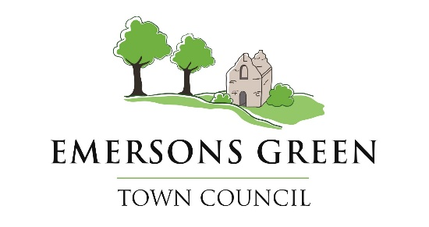
Name: Cllr Abi Cohen (Chair)

Date:

Signed:

Minutes of the Youth Work Committee

held in the Council Chamber, Emersons Green Town Council,

18:00hrs on Thursday 16th October.

Present: Councillors Simon Budd, Abi Cohen, Lynne Paraskeva, James Hunt,
Tina Potter and Daryl Hembrough.

In attendance: Shea Stew (Youth Liaison Officer)

Public: No Members of the public were present.

Notes: The meeting began at 18:00hrs. All resolutions were passed with a majority vote, by a show of hands, unless otherwise stated.

The Committee Chair welcomed everyone present at the meeting and explained the emergency procedures and the process of this meeting.

Welcome and Introductions.
The Youth Liaison Officer was introduced to all Councillors present.

YWC_2025.044 Declaration of Interest – Localism Act 2011.
No interests were declared.

YWC_2025.045 Public Participation.
Three Members of the public were present.

YWC_2025.046 Minutes.
Resolved Minutes were resolved from the Youth Committee 18th September 2025

YWC_2025.047 Outstanding items.
Resolved The Youth Liaison officer updated on outstanding items.
- Masters and the Community Club on Wheels. The base is down.
- SNG Housing Association and Lyde Green project agreement agreed.
- Mangotsfield Car Project update.

YWC_2025.048 Correspondence.
The Youth Liaison officer provided updated information on correspondence
Received.
- Parking near the Sainsburys site.
- Black horse Fields and littering.
- Creative Youth Network and positive third session engagement.
- Meetings with the police regarding ASB.

YWC_2025.049 Developing Youth Provision Strategy.
The Committee Clerk provided an update on the youth strategy and updated on
The development of the community club on wheels project.
- Rodway Tracks and working with young people.
- Updated on street based engagement statistics.
- Meetings regarding where the community club on wheels will be homed.
- Staffing the community club on wheels.

YWC_2025.050 Next Meeting.
- To note the next meeting of the Youth Committee will be on:
Thursday 20th of November 2025 at 18:00hrs in the Emersons Green Town Council Chamber.

DATES & TIMINGS

The meeting closed at 18:50hrs

